**READING LESSON GUIDE FOR TOP CLASS**

**TERM ONE 2023**

**Lesson 1**

Orientation

-Learning our names

-Visiting the toilets and latrine

-Imitating animal sounds

-Reciting rhymes , singing etc

**Lesson 2**

Revision of sound set 1 to 3

s a t i p n

ck e h r m d

g o u l f b

**Activity**

Copy an learn

**Lesson 3**

Fill in the missing vowel sounds

a e i o u

a ___ i ___ u

___ e ___ o ___

**Lesson 4**

Revision of consonants

Listen and write

b c d f g h i k l m n p

q r s t w x y z

**Lesson 5**

Revision of syllables

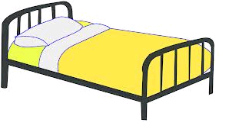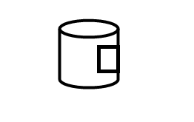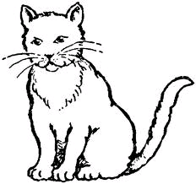Fill in the missing syllables

t d n

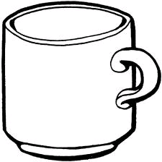

t p

**WEEK TWO**

**Lesson 1**

Vowels

Copy and learn

a e i o u

**Lesson 2**

Match vowels to pictures

a

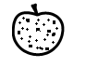e

i

o

u

**Lesson 3 consonants**

Copy and learn

b c d f g h

j k l m n p

q r s t v w

x y z

**Lesson 4**

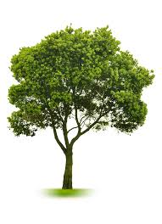Write the consonant for the picture

**Lesson 5**

Fill in the missing consonant

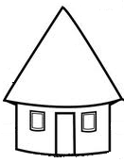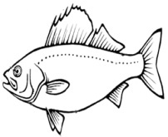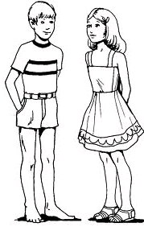 



**WEEK 3**

Consonant blends

**Lesson 2**

Circle the consonant blend

St one br oom cl ass

**Lesson 1**

Copy and learn

st br cl fl gr sn gl fr bl pl nt mp

cr sk str spr

**Lesson 3**

Tick the consonant blend for the picture

|  |  |  |  |
| --- | --- | --- | --- |
|  | br | cl | st |
| http://t2.gstatic.com/images?q=tbn:ANd9GcQJ-9xIdg-3YfMkM4No4gcEN3Gr4kAKZFU71e6LgdjyDnLGv9Ca | fl | pl | gr |
| [http://ts1.mm.bing.net/images/thumbnail.aspx?q=4973976336531764&id=439278ff99047aefdfc31a4ea46b8d96&index=newexp&url=http%3a%2f%2fwww.wpclipart.com%2fanimals%2fsnake%2fsnakes_3%2frattle_snake.png](http://www.bing.com/images/search?q=www.google+image+snake+&view=detail&id=B2F20F56F4B4857DF3EAA13F83ADEB5B696F5EA0&first=0&FORM=IDFRIR) | dr | sn | cr |
| [http://t1.gstatic.com/images?q=tbn:ANd9GcT1U_c3ruP7T7WGPZHalB-OySkuJqWCjU96tbKZWH5VsXwWhGEY5bRPoA](http://www.google.co.ug/imgres?imgurl=http://www.honrygroup.com/Plastic_Basin.jpg&imgrefurl=http://www.honrygroup.com/Honry-Links%20Your%20Plastic%20Materials.html&usg=__CgWEkmpZNapUSe3nQxJvTR-K8m4=&h=360&w=360&sz=15&hl=en&start=1&zoom=1&tbnid=qX99uOjvkK6thM:&tbnh=121&tbnw=121&ei=VJa2TcadOMedOtC-0JEP&prev=/search?q=plastic+basin&hl=en&sa=N&gbv=2&tbm=isch&itbs=1) | pl | fr | nt |
|  | gl | sk | dr |

Lesson 4 syllables

Copy and learn

ba be bi bo bu

ma me mi mo mu

ga ge gi go gu

fa fe fi fo fu

da de di do du

**Lesson 5**

Form words and read

ma - t = pe – n = be – d = po – t =

bu – s = ti – n = si – t = ju – g =

lo – g =

**WEEK FOUR**

**LESSON 1**

Read and draw

pot tin bed pen

bus jug mat boy

Write words correctly

atc xob snu

**Lesson 2**

Copy and learn

cla cle cli clo clu

dra dre dri dro dru

sta ste sti sto stu

fla fle fli flo flu

**Lesson 3**

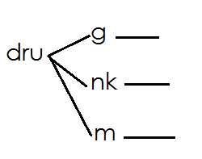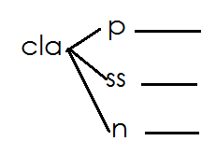Form words

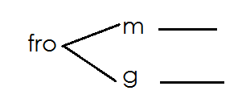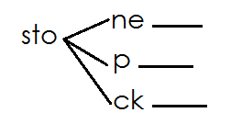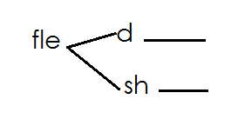

**Lesson 4**

Write a word for the syllable

te du bo hi

bla pa bla dre

ski plo dru

**Lesson 5**

Read and write

-Brenda has a black bag.

-Sarah has seven spoons.

-Frogs crow in the rain.

-Plants grow in grass.

-The class in clean.

Get fresh apples from the baskest.

**WEEK FIVE**

Lesson 1 Digraphs

Read and write

sha she shi sho shu

shall shed ship shop shut

shadow shell shift shock

fish splash brush slash shirt

short shelf shark she wash

**Lesson 2**

**Underline sound “ch” in words**

Cha che chi cho chu

chart chest chin chop church watch

charm check chick chair chunt march

chard chelse chill chalk match bench

**Lesson 3**

Ring words of “sh” sound

church sheep dish

shop chair chain

chest ship bench

shirt brush chill

fish shell chalk

**Lesson 4**

**Form words**

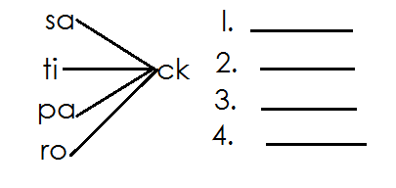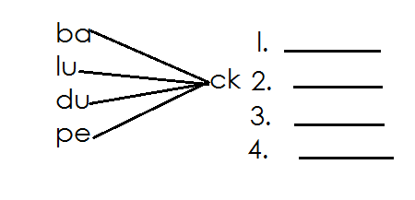

**Lesson 5**

Match words with the given sound

Ph – photo elephant alphabet phone graph nephew

phonic Philip Joseph pharmacy

gh _ cough enough tough laugh dough

**WEEK SIX**

Lesson 1

Cross sound “ng” in the words

King long sing wing thing ring lung orange

spring strong hung swing bring bang panga

**Lesson2**

**Read and write**

the then they mother

them those there brother

with that this

these their other father

**Lesson 3**

Underline sound the in words

mouth tin thing thumb think smooth moth thunder south Ruth theme thorn north thirst thirteen thirty Timothy month

**Lesson 4**

Read and write

Am sick of cough.

Sing for me a song.

This is my thumb.

Tie the chain on the bench.

The King can laugh.

Come with them.

Bring back my sack.

Joseph sat on the chair.

**Lesson 5**

Read and draw

|  |  |
| --- | --- |
| A thin fish in a dish. |  |
| Dan has a phone . |  |
| That is my brother. |  |
| Philip’s photo is nice. |  |
| This is my thumb. |  |
| Asha has a big ship |  |

**WEEK SEVEN**

Lesson 1

“Wh” words – Read and learn

why which when while what whose who where whom whistle etc

**Lesson 2 Oral**

Asking questions and answering questions

What is your name?

Why do you come to school?

Whose bag is this?

Where do you live?

Who are your teachers?

Which school do you go to?

Whom do you live with?

**Lesson 3**

Form words and read

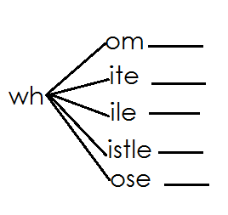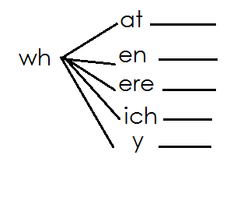

**Lesson 4**

Listen and write

who why what when which

**Lesson 5**

Read the story and answer questions orally.

On Monday morning, Sarah was going to school with her brother Sam. The name of the school was Salama Nursery School. Sarah saw a madman with a stick. She was afraid and cried for help. A woman came and escorted them to school.

**Questions**

Where was Sarah going?

What did Sarah see?

Which school was Sarah going to?

Who had a stick?

When did Sarah see the madman?

With whom was Sarah?

Why did they cry for help?

**WEEK EIGHT**

Alternative sounds

Lesson 1

Read and write

“ai” family

ai ae a – e ay eigh ei ey a- y

**Lesson 2**

Fill in sound “**ai**” and each

r n j n m d ch n tr n sn l

i d n l p d gr n cl m

sp n ch r g n

**Lesson 3**

Tick words with “**ae**” sound

aeroplane name date aerogram table

shade aerobics safe rape aerophone

wave graze aerial snake gate chase

**LESSON4**

**Read and write**

save late shape came take graze page made male place change lake plate face scale spade same plane graze space square case hate gave amaze blade age cake game Jane paper taste slate grave shame face shake lame etc

**Lesson 5**

Read and underline words with **ai** , **ae** and **a- e** sounds

The main gate is open.

That is a train.

I can see an aeroplane.

The safe is locked.

Am late for school.

Wait for Jane.

The snake is in the rain.

**WEEK NINE**

**Lesson 1**

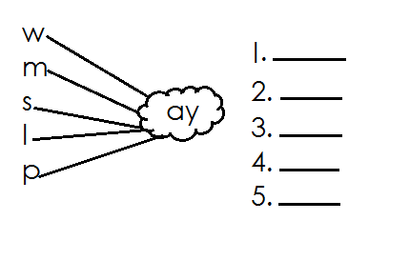Form words and read

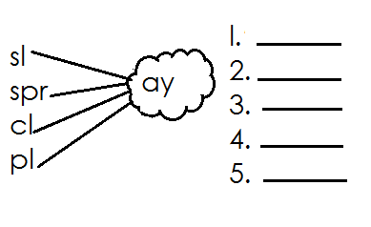

**Lesson 2**

Cross words with **“ei”** sound

baby heir lady their Mary protein

vein lazy rein crazy many leisure

any reich daisy either neither

**Lesson 3**

Sort the words and group them to the given sounds.

eight obey they neighbour height

grey weight neigh prey weight

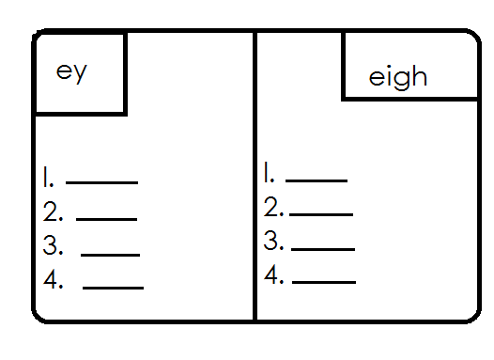

**Lesson 4**

Write two words for the given sound

ai a – e

ay ey

a - y

**Lesson 5**

Match the sound to its word

a e height

a y train

a- e baby

e y snake

a i aeroplane

eigh they

a – y pray